From Vine to Bottle

Immerse yourself in the captivating journey of our grapes, which, from winemaking treasures, become the bottled expression of our passion and heritage. At Château Lastours, each step of our winemaking process reveals a story of dedication, respect for nature, and the magic that transforms fruit into great wine. Welcome to the heart of the vineyard and cellar, where tradition and art meet.

1. Pressing – Where It All Begins

As soon as they arrive, the freshly harvested grapes are brought to the press. This delicate step releases the first juices for our white and rosé cuvées. These juices, called *musts*, are then clarified through settling (*débourbage*) before being transferred to concrete or stainless-steel vats. This is the prelude to all the estate’s finest wines.

2. Alcoholic Fermentation – When Sugar Becomes Wine

Alcoholic fermentation begins: the yeasts naturally transform the sugar in the must into alcohol. Here, every detail counts! We meticulously monitor the temperature to preserve freshness and allow the yeasts to work in the best conditions.

For our red wines, a unique expertise is pumping over. This technique involves circulating the must from the bottom to the top of the vat, thus promoting the extraction of tannins, color, and aromas. A maceration period follows, monitored and tasted daily, to bring balance and character to each vintage.

3. Malolactic Fermentation – Softness and Stability

After alcoholic fermentation, a second transformation occurs thanks to natural bacteria. Malic acid turns into lactic acid, softening the wine while stabilising its structure. Essential for our red wines, this fermentation is also carried out on certain white cuvées to fully reveal their personality.

4. Racking and Vat Draining – Selection and Precision

After maceration comes *écoulage* — separating the *free-run wine*, synonymous with finesse, from the *press wine*, which is more powerful in character. The remaining solids (*marc*) are pressed gently to extract every drop. Each component is then treated according to its character to create our finest blends.

5. Blending – The Emotion of Creation

Blending is the heart of our creativity. We carefully select different vineyard parcels and grape varieties before tasting them individually. Through the subtle art of blending, great cuvées are born — authentic reflections of our terroir and our vision.

6. Barrel Ageing – The Art of Time

Our wines continue their development in French oak barrels, the key to developing their aromas and refining their texture. Barrel ageing, between November and December, brings roundness, complexity, and depth to each vintage, thanks to a multitude of natural transformations.

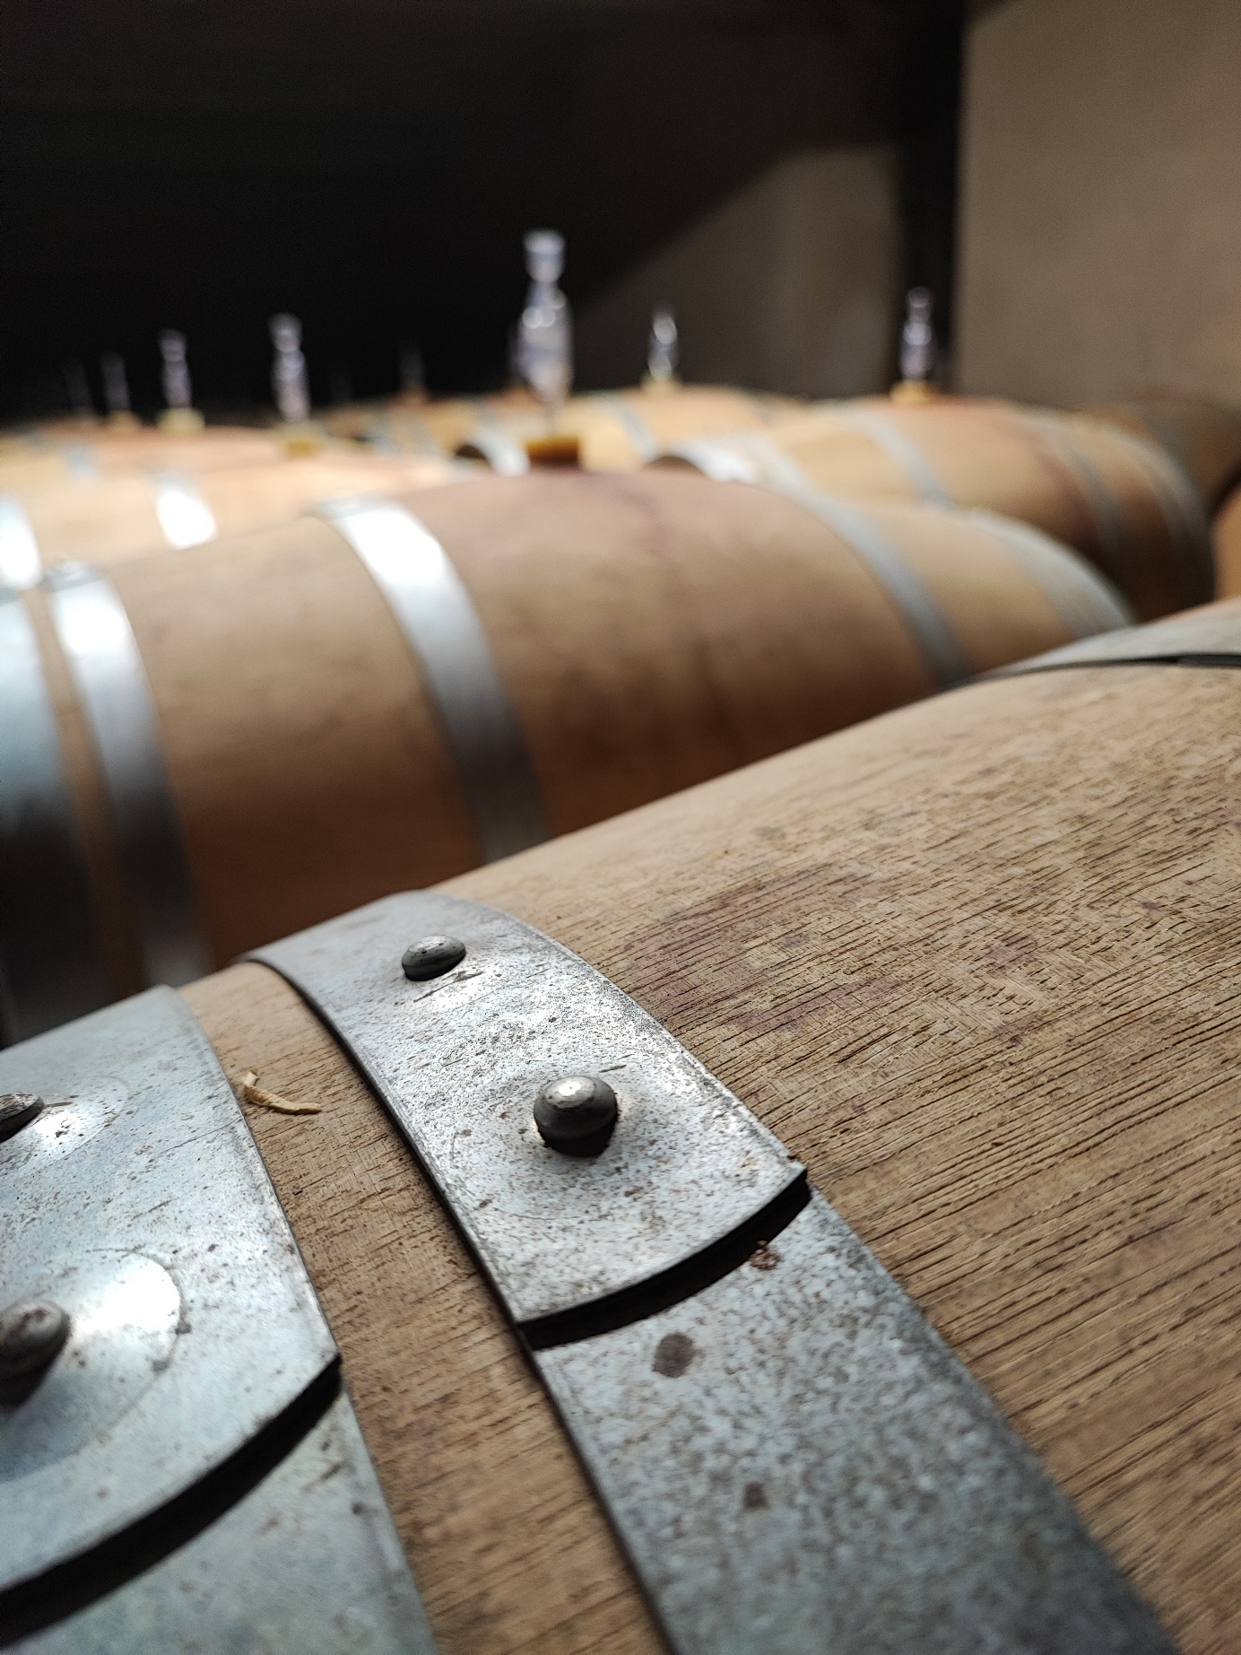

7. Bottling – The Birth of a Wine

Every step leads here. We bottle our wines on the estate under a neutral atmosphere to preserve their aromatic freshness and guarantee quality all the way to your table.

8. Topping Up – Constant Care

Among our daily tasks in the cellar, *ouillage* (topping up) is crucial: replenishing the barrels to compensate for the natural evaporation and prevent oxidation. This meticulous care preserves the balance and finesse of our wines throughout their ageing period.

Did You Know?

From harvest to blending, every step combines tradition and innovation. Our team works tirelessly, day after day, to ensure excellence and authenticity in every bottle — while respecting the environment and the core values of our estate.

Want to learn more or discover our cuvées?  
Contact us or visit the estate to experience the heart of winemaking — where it all begins !